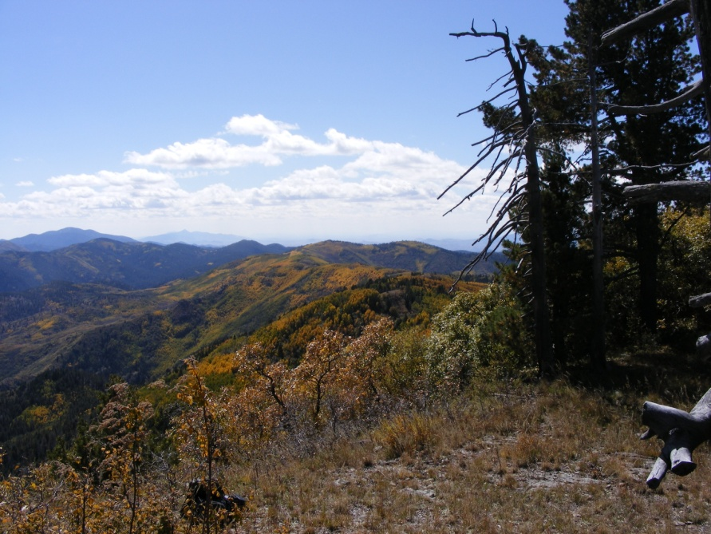
OUTREACH NOTICE

Gila National Forest
Supervisors Office
Silver City, New Mexico

Interdisciplinary Geographic Information System Specialist GS-101/401/1301-09 (One Position)

Please respond by August 3, 2016

The Gila National Forest will soon be advertising a vacancy for an Interdisciplinary Geographic Information System (GIS) Specialist, GS-101/401/1301- 09. The position is a permanent full-time appointment, and will be located at the Supervisor’s Office in Silver City, New Mexico. The purpose of this Outreach Notice is to determine the potential applicant pool for this position and to establish the appropriate recruitment method and area of consideration for the advertisement (i.e. service-wide, government-wide). Responses received from this outreach notice will be used to make this determination.

Interested applicants or those desiring more information should contact Arthur Telles, Natural Resources and Planning Staff Officer, at atelles@fs.fed.us

VACANCY ANNOUNCEMENT

The vacancy announcement for this position will be posted on the U.S. Government's official website for employment opportunities at www.usajobs.gov.

INTRODUCTION

The position has the responsibility for supporting managers and resource specialists in the use of geospatial technology and Geographic Information Systems (GIS) for land, natural resources and ecosystem management.

Duties include:

Data Management

Works with managers and resource specialists to determine type, amount and level of information required to develop and analyze ecosystem management alternatives. Assists with developing data dictionaries, data models, and metadata for multi-disciplinary information and geospatial applications. Converts geospatial information and remote sensing imagery into GIS databases. Assists with the organization and maintenance of resource information and data to facilitate analysis across multiple disciplines including but not limited torecreation, vegetation, wildife, water, planning, engineering and fire.

Geospatial Analysis

Applies applicable principles to facilitate geospatial model design and analysis procedures related to natural resource and relevant socio-economic data and products. Manipulates and analyzes geospatial data to support resource management decisions for multiple resource, jurisdictional, and ownership units or a large geographical region. Performs multi-scale and/or multi-resource analysis in support of planning, analysis, and monitoring activities.

Cartography and Map Design/Production

Compiles natural resource, topographic, and cartographic data for creation of thematic map products and presentation materials for multi-disciplinary resource management planning, preparation of environmental and social assessments, environmental impact statements and other projects supporting natural resource management decision making. Operates complex computer systems and software packages and uses established procedures to produce intricately detailed maps and graphics for the many varied Forest resource programs, planning documents, and a variety of other requirements. Applies geographic and cartographic principles to the resolution of multi-disciplinary issues in geospatial database construction and map compilation.

Training and Support

Provides advice and recommendations on sources, standards, integrity, compatibility, and cost efficiency of natural resource and socio-economic information. Conducts informal training and provides technical assistance to GIS software users in the development, storage, retrieval and analysis of data.

Gila National Forest

Every National Forest offers its own unique qualities. The Gila's beauty is in its diversity of rugged mountains, deep canyons, meadows, and semi-desert country. It is one of the more remote and least developed National Forests in the southwest. The Gila is the sixth largest national forest in the continental United States, covering 3.3 million acres of forest and range land.

The forest has a rich history of the Mogollon and Apache Indians, Spaniards, Mexicans, ranchers and prospectors. A few of the personalities from the past that have left their mark in the Gila include Apache Chiefs Mangas Coloradas and Geronimo, conservationist and author of the Sand County Almanac Aldo Leopold; Billy the Kid and other outlaws; and renowned lion hunter Ben Lilly.

Another unique beauty of the Gila National Forest is its wilderness. The Gila, Aldo Leopold, and Blue Range Wilderness areas offer unparalleled hiking and horseback riding. The 558,065-acre Gila Wilderness, created in June 1924 at the urging of the conservation pioneer Aldo Leopold, was the world's first designated wilderness.

Community: Silver City (or related area) www.townofsilvercity.org and the surrounding communities of Bayard, Santa Clara, Tyrone and Hurley are located in southwest New Mexico. Main access to Silver City is via Highway 180 north from Interstate 10 at Deming, NM. The elevation is 5,900 feet above sea level. The population of Silver City is approximately 13,000 and Grant County is about 29,000. Silver City was recently selected as one of the healthiest places to live and retire. It placed in the top 1% of over 3,000 communities our size or larger. Downtown Silver City is undergoing a revitalization effort and features many locally-owned shops and lots of art galleries. The community has two libraries and churches of all denominations. There are two newspapers, motels, radio stations, city and county offices and local retail businesses. Area attractions include City of Rocks State Park, Historic Pinos Altos and Western New Mexico University Museum http://www.wnmu.edu/univ/museum.htm.

Climate: Silver City boasts four gentle seasons. The average annual temperature is 54 degrees. May is the driest month of the year while July is the wettest. The annual average precipitation is 15.69 inches.

Medical: Silver City has a Regional hospital http://www.grmc.org/, several medical clinics, ambulance service, an emergency care clinic, and physicians of all specialty areas, dentists and nursing homes.

Schools: Grant County has two public school districts. There are several private schools and alternative schools. Western New Mexico University www.wnmu.edu/ offers four-year programs and two year technical programs in areas such as education, nursing, basic arts and sciences and several graduate programs.

Employment: Major employers are Freeport-McMoRan Copper & Gold, Gila Regional Medical Center, Silver City Schools, Western New Mexico University, Walmart, Town of Silver City, Grant County, and the Gila National Forest.

Housing: Rentals range from $600-$1000 per month for an average three bedroom home/apartment. Prices of single family homes range from $85,000 and up.

Transportation: The nearest commercial airports are in El Paso, TX (3 hours), Tucson, AZ (3 hours) and Albuquerque, NM (4 hours). Grant County airport provides daily services. There is a shuttle service for transportation to Las Cruces and El Paso and a local transportation service to all the surrounding communities.

Additional Information: For additional location information visit the following web sites:
Gila National Forest Website | www.fs.fed.us/r3/gila
Grant County Chamber of Commerce | www.silvercity.org
Silver City Chamber of Commerce | www.townofsilvercity.org

OUTREACH RESPONSE FORM
Interdisciplinary Geographic Information System Specialist GS-101/401/1301-09 (One Position)

Please return by August 3, 2016

If you are interested in this position, please complete this form and email to Arthur Telles, at atelles@fs.fed.us If you have questions about the position call (Arthur Telles 575-388-8417).

PERSONAL INFORMATION:

Name: |  | Date:

Address:

Email Address:

Phone:

Are you currently a Federal employee? | YES: |  | NO:

IF YES: Current Agency and location:

Current Title/series/grade/Level:

Type of Appointment: | Permanent |  | Term |  | Temporary

If you are not a current permanent employee (career or career conditional), are you eligible for appointment under any of the following special authorities?
Person with Disabilities
Veterans Recruitment Act
Former Peace Corps Volunteer
Disabled Veteran with 30% Compensable Disability
Pathways Program
Veterans Employment Opportunities Act of 1998
Other, please describe:

Briefly describe your qualifications/interest in this position (type answer into box, which will expand as needed):

Thank you for your interest in our vacancy!

USDA is an equal opportunity provider, employer, and lender

