Lesson 3 – Spatial Interpolation
Lab 3
The data for this lab is contained in the WeatherData.gdb contained in the Lab1_Interpolation folder. For this lab you will work with surface weather observations for the United States for a particular day and time (May 23, 11:00 AM PT). The goal is to make a weather map that combines elements from these two maps:
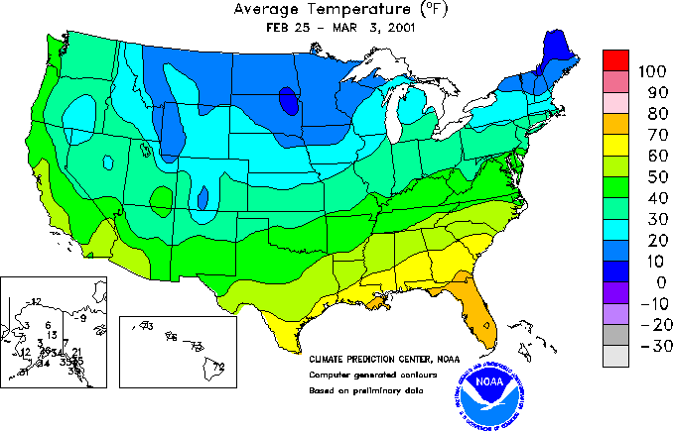
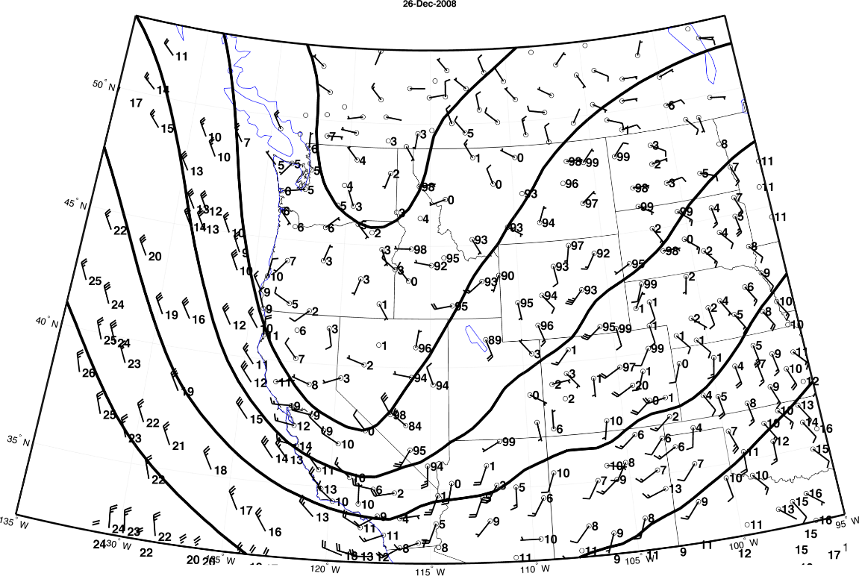
The colorful map above shows one thing: temperatures in degrees Fahrenheit symbolized every 10 degrees.

The black and white map above shows three things: 1) Isobars (the thick black lines) which are lines of equal barometric pressure; 2) Wind speed shown by the flags on the wind barbs; 3) Wind direction show by the angle of the wind barbs - they point into the direction from which the wind is coming.
Though the goal of this lab is to make a weather map showing these four elements, you will be experimenting with interpolation tools for generating both a temperature and a raster surface.
Be sure to keep a log of the analysis you perform (a process summary) as you will need to submit this.
Open Lab1_Wx.MXD. The map contains a polygon layer showing the outline of the lower 48 United States and points representing weather stations.
- Open the Weather feature attribute table. Notice the many fields containing weather observations. In this lab you will use the TEMP_F_ field which contains temperatures in Fahrenheit and the SLP field which contains surface level pressures in millibars to interpolate raster surfaces. Later in the lab, you will use the RSPD_KT_ field (wind speed in knots categorized every 5 knots) and the WINDDIR field (wind direction in degrees) to symbolize the points.

Questions:
- What are the no-data values for each of these 4 attribute fields?
- Excluding the no data values, what is the range of values for each of these fields?

Use the skills you’ve learned from the Making Spatial Decisions Using GIS book to set the map properties and make copies of the MXD. You will need them when it is time to make maps.

Part 1: Create a Temperature Map
- Select all of the surface observations that have valid temperature values and export it to a new feature class called GoodTemps.
- Now you will experiment with 3 of the Spatial Analyst interpolation tools: Kriging, IDW, and Spline. In each, the Z value field will TEMP_F_.
- Run each of these analyses using the default settings for each tool. Be sure to document your work in the process summary.
- Symbolize each resulting raster using the following temperature classification color scheme:
- Create a map of each modeled temperature surface. Pay attention to how the raster renders. If you zoom in, you may notice a jagged boundary between different temperature zones. To smooth this out, go into the raster layer properties > Display tab and change the option for “Resample during display using:” to either bilinear interpolation or cubic convolution (experiment with each).
Questions:
- Which interpolator produced the best looking map?
- Compare each model’s range of temperature values compared to the observed temperatures. (To do this, you will have to look at the actual range of temperatures in the raster surface and not the range (given in the color ramp above) that you used to symbolize them.) Does the model’s range of values match the observed range of values?

Now experiment a little and see how changing some of a tool’s parameters affects the output. Choose the two best interpolators (based on your results so far). Research each of these interpolators to get a sense of what parameters to change and how to do so. Check the ArcGIS for Desktop Help and also see if there is any information on the internet about appropriate settings for interpolating temperature values. Re-run each of your two best interpolation models making your changes to the parameters. Instead of experimenting, I want you to use the following:
- For the IDW model, re-run it with a power setting of 3 (instead of the default value of 2)
- For the Kriging model, re-run using a semivarigram model of exponential (instead of the default spherical)
- Document your analysis, making note of the parameter values you change.
- Use the same classification and color scheme you used above so that you can easily compare your temperature rasters.
- Create maps for each of your experimentations.
Questions:
- Compare and contrast the results of using the default parameters and changing them. Which model and parameters seems to produce the best looking map?
Test the Models
Now you will test the best two models. First, select the 2 best models from all of your temperature maps. To test a predictive surface, you remove some of the data points and perform the analysis again using the same tool and parameters. Then you test to see how well the modeled surface does at predicting the temperature for the removed points.
- Select the following 10 points from the GoodTemps feature class based on the ID field: KCH, KGB, KGFL, KHR, KLCI, KNID, KRC, KSP, KSZT, KUIL
- I have created the Temp_Test and the Test_Stations for you (see attached zip file).
- Perform the interpolation again using the two best models and parameter settings you identified above. This time use TempTest as the input.
- Assess how each new model performs at predicting the temperatures of the test stations.
  - Create a table showing each model’s predicted value and the actual observed value of each of the 10 test stations. (Hint: you can use the Identify tool to get the pixel value of a raster.)
Question: Which model does a better job?

